**Installing Phenocam**

Phenocam requires a considerable amount of built-in Matlab functionality to support graphical and statistical operations. Hence, to use Phenocam, you have to install the Matlab Compiler Runtime (MCR) as we would any other Windows program. This installation differs from a licensed Matlab copy as it only supports the GUI – it is not possible to interface with Matlab in any other way.

Click on *phenocamW32_pkg.exe/phenocamW64_pkg.exe* and follow the prompts to install the MCR as if you were installing any other Windows software program. This installation will also create a folder in your C drive for Matlab program files.

During installation, you will likely be asked to also install *VCREDIST_V90_X86* and *VCREDIST_X86*. Click **Install** to install them. The full installation should take 5-10 minutes.

Once installed, you should have the following four files:

* *MCRInstaller.exe* - ~196 Mb
* *PhenocamW32.exe* or *PhenocamW64.exe* - ~2Mb
* *PhenocamW32_pkg.exe* or *PhenocamW64_pkg.exe* - ~195Mb
* *readme.txt* – 1Kb

You can erase the *MCRInstaller.exe* and *phenocamW32_pkg.exe/phenocamW64_pkg.exe* files. Be sure to retain the *phenocamW32.exe (32-bit systems)/PhenocamGUI.exe (64-bit systems)* file which can be moved to a different folder if you like.

**Considerations before use**

The Phenocam Tool was designed to conform to the file structure and file naming conventions of the Phenocam (http://phenocam.sr.unh.edu) project. You can use the available test data from the Bartlett site as an example. Below are the specifications.

Each photo file name must follow the below format:

site_YYYY_MM_DD_hhmmss.jpg  
where

YYYY - year, MM - is month, DD is day, hh is hour, mm is minute and ss is second.

The photos must be organized by year and month where each month is represented using a two-digit number (i.e. 01, 02, 03… 12).

**Using the GUI**

To run Phenocam, double-click on the *PhenocamW32.exe (32-bit systems)/PhenocamW64.exe (64-bit systems)*. This will open the Phenocam Dialog window, as shown below.

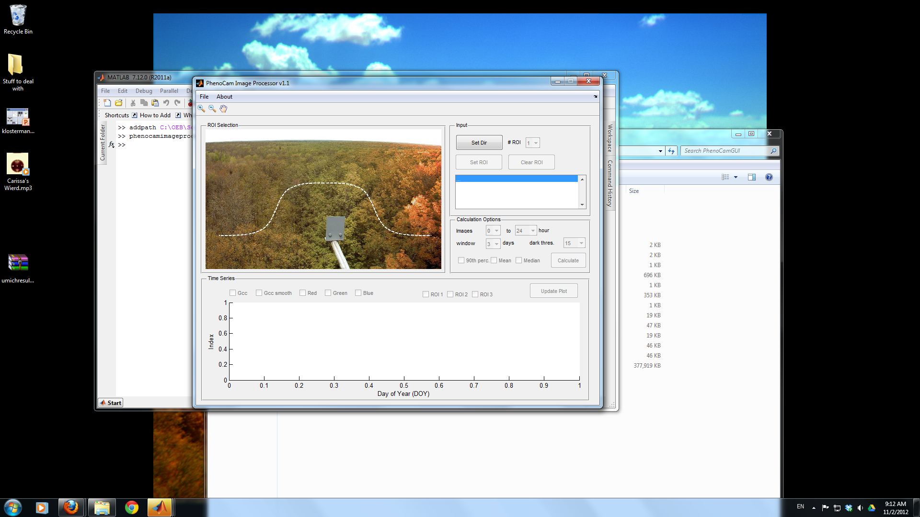

Please follow instructions in the correct order as described below. The program will not respond or fail if done in the incorrect order.

1. Click on **Set Dir** and direct the Windows Explorer window to a folder containing your imagery archive. The program is designed to operate on one year’s worth of imagery at a time. And so, if we wanted to process Bartlett imagery, we would direct it to Bartlett\2006 and press **OK**. One image should appear in the viewing window to the left. You can set which picture appears by selecting it from the list produced at right.
2. Choose the number of Regions of Interest (ROI) using the menu, **# ROI**. Then, click on **Set ROI** to create the ROI(s). Designating a ROI will depend on the science question being asked: it may range from one particular tree to a stand dominated by one species or even the entire vegetated area. As a rule of thumb, the ROI should be large enough, however, that any minor shifts in the field of view over time will not substantially alter the delineated region. Left-click on the image to enter nodes of a polygon and right-click to finish each polygon. Click on **Clear ROI** if you need to start over. If you want to zoom in/out or pan the image, you can use the corresponding icons (magnifying glasses and hand) in the upper left-hand corner.

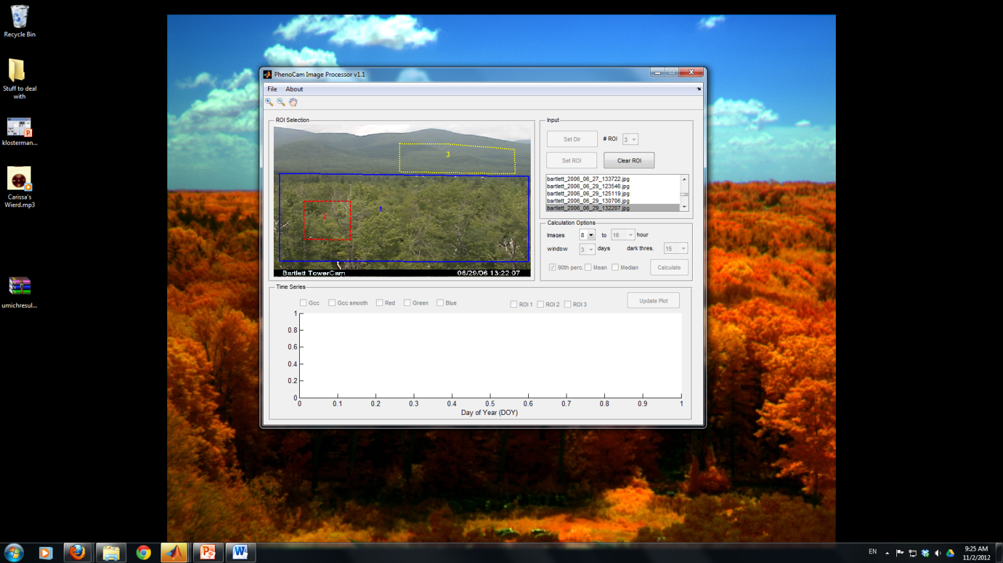

1. We can now set the **Calculation Options**. First, set the minimum (left pull-down menu) and maximum (right pull-down menu) hour of the images to include in analysis next to **Images**. Generally, one should set the hours to remove most nighttime images from analysis, although there is another filter that separately removes very dark images.
2. We will now choose the filtering window. This is the number of days over which the data will be smoothed and filtered – use the pull-down menu next to **Windows** to enter a number. We generally suggest a window of 3 days based on prior research.
3. Choose a darkness threshold using the menu next to **dark thresh.** This number dictates the minimum digital number value (pixel brightness). We generally suggest a value of 15%.
4. Lastly, choose either **90th perc.** (percentile), **mean** or **median** filtering using the radio buttons. This smoothing will produce a time series of the 90th percentile, mean or median value at the interval (window) chosen above. At this point, the dialog box with typical settings should appear as below:

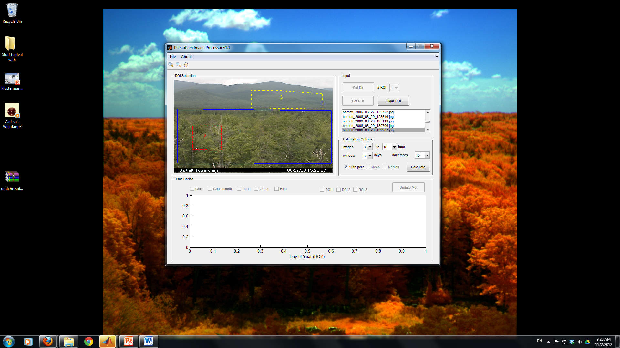

1. Click on **Calculate**. A progress bar will open up.
2. After calculating, you can display both the raw results (**GCC, red, green** and **blue** values for every photo) and smoothed results (**GCC smooth**) using the radio buttons. The GCC smoothed data represent the results from filtering (90th percentile, median or mean) over the given time window (e.g. 3-day, 5-day). To switch between plots, click on **Update Plot**.
3. You can save your results (as a normal, comma-separated-value text file) and the ROI file (as a binary Matlab file) by clicking on **File>Save ROI and File>Save Time Series Data**, respectively.
4. To analyze an additional year of data from another folder, click on **Clear ROI** and **Set Dir** to select the new folder. To reload a saved ROI, go to **File>Load ROI**.

**Special Considerations**

Because of the way that ROIs are interpreted by Matlab, all photos from the entire year analyzed must have identical dimensions. Even a minor change from, say 1024 x 1096 to 1024 x 1090 would cause the output results to be entirely unreliable. However, camera settings may be changed and/or cameras may be replaced. If that is the case, take careful note of when any changes may have occurred and run the Phenocam Tool twice – once for the first photo dimension and again for the period after the change in dimensions - or more if there are multiple changes. For instance, if a camera change occurred on March 24th at 11:36, run Phenocam twice. On the first run, be sure to use a photo from before that date to draw the first ROI. On the second run, be sure to use a photo from after March 24th to draw the second ROI and run again. You will then want to merge the output text files to create one representative GCC time series for the year. The same process should be followed if there are substantial changes in the field of view of the images which render the ROI useless for a latter period of the year.

This manual editing is of course, not ideal. For users with a high number of changes in the field of view or dimensions, or for those processing a large number of sites, Matlab code is available for more efficient data processing. However, a Matlab license is needed.

**Uninstalling Phenocam**

As mentioned above, the MCR operates like any other Windows software program. Go to **Control Panel > Programs and Features** to uninstall the Matlab Compiler Runtime 7.15 program. You can also erase the *phenocamW32.exe/phenocamW64.exe* and *readme.txt* files from your computer.